# Lab: Arrays

This document defines the exercises for the ["C++ Fundamentals" course @ Software University](https://softuni.bg/trainings/4263/cpp-fundamentals-november-2023).

Please submit your solutions (source code) of all below-described problems in [Judge](https://judge.softuni.org/Contests/4478/Arrays-Lab)

## Day of Week

Write a program that:

* Reads an **integer number** from the console
* If the number **is in range [1; 7]** you have to print:
  + **Monday** if the number is **1**
  + **Tuesday** if the number is **2**
  + **Wednesday** if the number is **3**
  + **Thursday** if the number is **4**
  + **Friday** if the number is **5**
  + **Saturday** if the number is **6**
  + **Sunday** if the number is **7**
* If the number is out of the given range above print: "**Invalid day!**"

### Examples

|  |  |
| --- | --- |
| **Input** | **Output** |
| 1 | Monday |
| 2 | Tuesday |
| 3 | Wednesday |
| 4 | Thursday |
| 5 | Friday |
| 6 | Saturday |
| 7 | Sunday |
| 0 | Invalid day! |
| 9 | Invalid day! |

## Print Numbers in Reverse Order

Write a program that:

* Read integer number **N** from the first line of the console (N < 100)
* Read **N integer numbers** from the next N lines of the console
* Print entered numbers in **reverse order**

### Examples

|  |  |
| --- | --- |
| **Input** | **Output** |
| 3  10  20  30 | 30 20 10 |
| 3  30  20  10 | 10 20 30 |
| 1  10 | 10 |

## Sum Even Numbers

Write a program that:

* Read an **integer number (< 100)**, which represents **size of the array**, from the first line of the console
* Read an **array of integer numbers** from the second line of the console
* **Sum only the even numbers** from the given array
* Print **calculated sum**

### Examples

|  |  |
| --- | --- |
| **Input** | **Output** |
| 6  1 2 3 4 5 6 | 12 |
| 4  3 5 7 9 | 0 |
| 5  2 4 6 8 10 | 30 |

## Reverse an Array of Strings

Write a program that:

* Read an **integer number ( < 100)**, which represents **size of the array**, from the first line of the console
* Read **an array of strings** (space-separated), from the second line of the console
* **Reverse** the given array
* **Print** reversed array on a single line (space separated)

### Examples

|  |  |
| --- | --- |
| **Input** | **Output** |
| 5  a b c d e | e d c b a |
| 4  -1 hi ho w | w ho hi -1 |

### Hints

* Read the array of strings
* **Exchange** the **first** element (at index 0) with the **last** element (at index n - 1)
* **Exchange** the **second** element (at index 1) with the element **before the** **last** (at index n - 2)
* Continue the same way until the middle of the array is reached

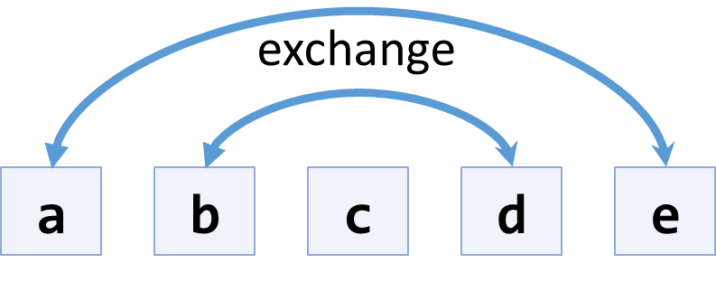

## Even and Odd Subtraction

Write a program that:

* Read an **integer number ( < 100)**, which represents **size of the array**, from the first line of the console
* Read **an array of integers** (space-separated), from the second line of the console
* Calculate the difference between the **sum of the even** and the **sum of the odd** numbers in an array
* **Print the difference**

### Examples

|  |  |  |
| --- | --- | --- |
| **Input** | **Output** | **Comments** |
| 6  1 2 3 4 5 6 | 3 | Sum even numbers: 2 + 4 + 6 = 12  Sum odd numbers: 1 + 3 + 5 = 9  Difference: 12 – 9 = 3 |
| 4  3 5 7 9 | -24 | Sum even numbers: 0  Sum odd numbers: 3 + 5 + 7 + 9 = 24  Difference: 0 – 24 = –24 |
| 5  2 4 6 8 10 | 30 | Sum even numbers: 2 + 4 + 6 + 8 + 10 = 30  Sum odd numbers: 0  Difference: 30 – 0 = 30 |

## Equal Arrays

Write a program that:

* Read an **integer number (< 100)**, which represents **size of the arrays**, from the first line of the console
* Read **two integer arrays from** the next two lines of the console
* **Arrays are identical if their elements are equal**
* Print on the console whether they **are identical or not**
* If the arrays are identical, find the sum of the first one and print on the console the following message:

"**Arrays are identical. Sum: {sum}**"

* Otherwise find the first index where the arrays differ and print on the console following message:

"**Arrays are not identical. Found difference at {index} index.**"

### Examples

|  |  |
| --- | --- |
| **Input** | **Output** |
| 3  10 20 30  10 20 30 | Arrays are identical. Sum: 60 |
| 5  1 2 3 4 5  1 2 4 3 5 | Arrays are not identical. Found difference at 2 index. |
| 1  1  10 | Arrays are not identical. Found difference at 0 index. |